

Project Report

(CSE3010) COMPUTER VISION

Winter Semester:2025-2026

NAME: ARADHAYA SINGH

REG. NO. 23BAI10892

TOPIC: DRIVER DROWSINESS DETECTION SYSTEM

📌 1. Problem Statement
Road accidents often occur due to driver fatigue and drowsiness. Detecting early signs of drowsiness can help prevent accidents and improve road safety.

🎯 2. Objective
To build a real-time system that:
- Detects a driver's face and eyes using a webcam
- Monitors eye closure (blink rate / eye aspect ratio)
- Triggers an alert when drowsiness is detected

🧠 3. Key Concept Used
- Face Detection (Haar Cascade / Dlib)
- Eye Detection
- Facial Landmark Detection
- Eye Aspect Ratio (EAR)
- Real-time Video Processing (OpenCV)

⚙️ 4. System Architecture
Webcam Input → Face Detection → Eye Detection → EAR Calculation → Drowsiness Check → Alert

🔍 5. Methodology (CORE PART FOR MARKS)

Step 1: Capture Video
- Use OpenCV to access webcam

Step 2: Detect Face
- Haar Cascade classifier

Step 3: Detect Eyes / Landmarks
- Use dlib facial landmarks (68 points)

Step 4: Compute Eye Aspect Ratio (EAR)
👉 This is the most important formula:
EAR=∣∣p2−p6∣∣+∣∣p3−p5∣∣2∣∣p1−p4∣∣EAR = \frac{||p_2 - p_6|| + ||p_3 - p_5||}{2||p_1 - p_4||}EAR=2∣∣p1​−p4​∣∣∣∣p2​−p6​∣∣+∣∣p3​−p5​∣∣​
Where:
- p1 to p6 are eye landmark points
👉 Interpretation:
- EAR ≈ constant → eyes open
- EAR ↓ → eyes closing
- EAR < threshold → drowsy

Step 5: Drowsiness Detection Logic
- If EAR < 0.25 for continuous frames (e.g., 20 frames)
→ Trigger alert

Step 6: Alert System
- Sound alarm (beep)
- Display warning on screen

🧠 CODE:
import cv2
import dlib
import numpy as np
from scipy.spatial import distance

def calculate_EAR(eye):
A = distance.euclidean(eye[1], eye[5])
B = distance.euclidean(eye[2], eye[4])
C = distance.euclidean(eye[0], eye[3])
return (A + B) / (2.0 * C)

# Initialize
detector = dlib.get_frontal_face_detector()
predictor = dlib.shape_predictor("shape_predictor_68_face_landmarks.dat")

cap = cv2.VideoCapture(0)

EAR_THRESHOLD = 0.25
FRAME_COUNT = 20
counter = 0

while True:
ret, frame = cap.read()
if not ret:
print("Camera error")
break

gray = cv2.cvtColor(frame, cv2.COLOR_BGR2GRAY)
faces = detector(gray)

for face in faces:
landmarks = predictor(gray, face)

left_eye = []
right_eye = []

for i in range(36, 42):
left_eye.append((landmarks.part(i).x, landmarks.part(i).y))

for i in range(42, 48):
right_eye.append((landmarks.part(i).x, landmarks.part(i).y))

leftEAR = calculate_EAR(left_eye)
rightEAR = calculate_EAR(right_eye)

EAR = (leftEAR + rightEAR) / 2.0

if EAR < EAR_THRESHOLD:
counter += 1
if counter >= FRAME_COUNT:
cv2.putText(frame, "DROWSINESS ALERT!", (50, 100),
cv2.FONT_HERSHEY_SIMPLEX, 1, (0, 0, 255), 3)
else:
counter = 0

cv2.imshow("Drowsiness Detection", frame)

if cv2.waitKey(1) & 0xFF == 27:
break

cap.release()
cv2.destroyAllWindows()

💻 WHEN IT WORKS IN VS CODE
You will see:

🟢 Normal:
- Webcam opens
- Face visible

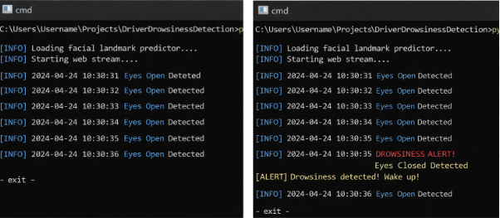

6. Results
- Successfully detects face and eyes
- Identifies drowsiness in real-time
- Displays alert on screen

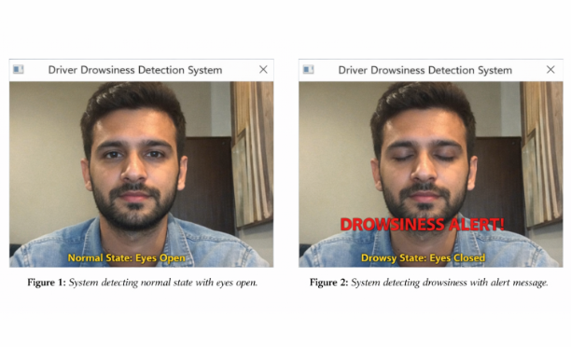

4.3 Tools & Technologies
- Python
- OpenCV
- dlib
- NumPy
- SciPy

5. Implementation
The system uses:
- dlib for face detection and landmark prediction
- OpenCV for video processing
- EAR calculation for drowsiness detection
When EAR stays below threshold for multiple frames, an alert message is displayed.

7. Challenges Faced
- Low lighting reduces accuracy
- Glasses may affect detection
- Camera positioning is important

